Our Inventory appears to be off occasionally.

This same thing happened a year ago, with the dispatched orders being recognized under the Sold stats but it does not actually come out of Inventory itself.

This has been happening again on several items in our catalog.

Inventory shows we have stock, In which we do not.

In the sold stats section, it has the items correctly.

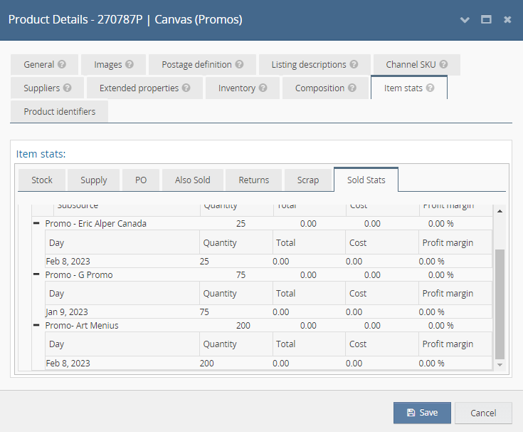

However in the Stock Item History it shows the orders not applied ?
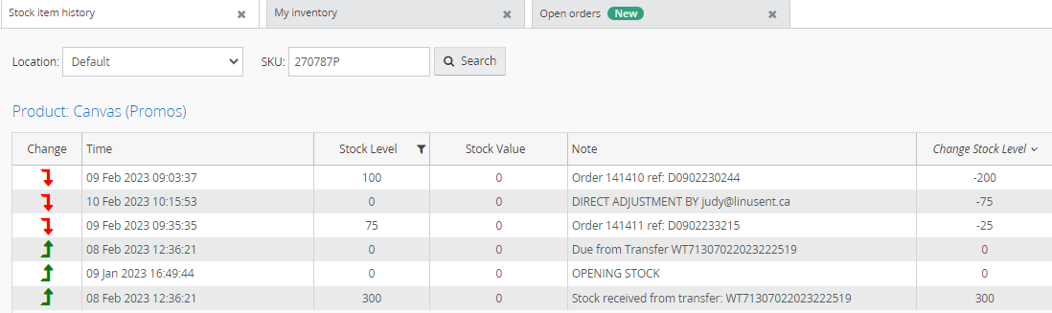

The orders that went through, were only recognized on 2 of the orders and not all 3. We are having to directly Adjust the inventory to have an up-to-date system. Making it impossible to check daily with multiple of orders coming in and processed.

Opening stock 300.
Order Feb 9 25 units sent in order reflected.
Order Feb 9 100 units sent in order reflected.

However, the order for G Promo 75 units processed and shipped February 8th is NOT reflected.
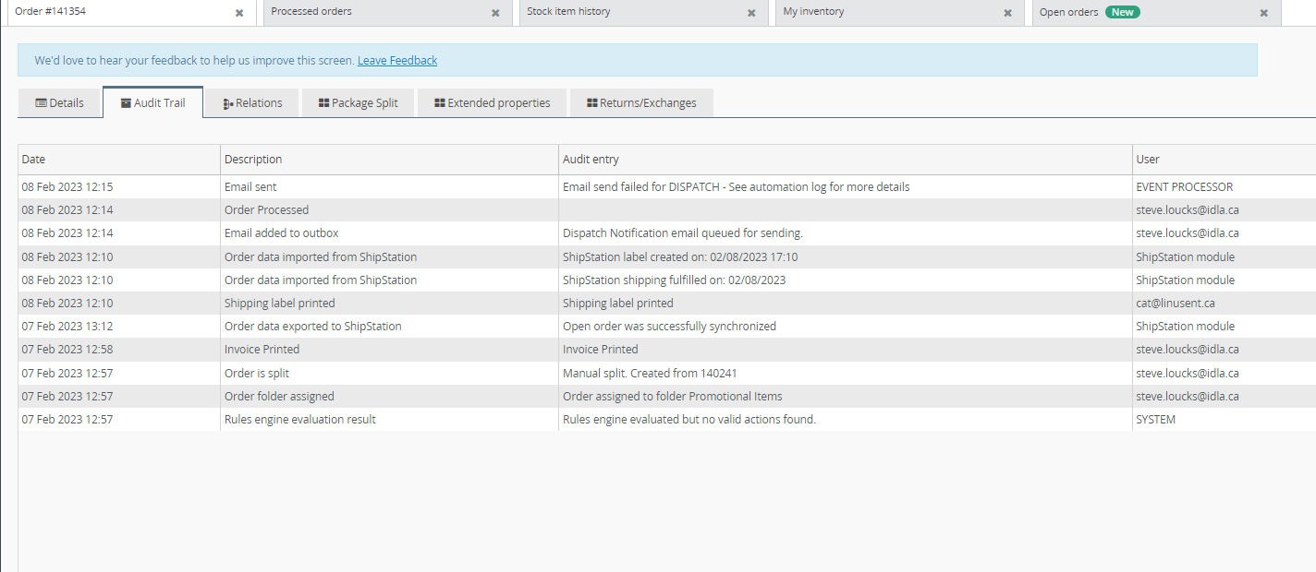

Can you please provide some insight or a fix to this issue above. As mentioned this has happened prior with other titles.
We need to ensure we have an accurate and updated and efficient Inventory site with the large volume we handle on a daily basis.

